MSTest Tests
Instructions

1. Introduction
VSTS (Visual Studio Team System) is a comprehensive platform for creation and management of automated and manual tests. VSTS provides unit-testing capabilities, both through an interface integrated in VS itself (see this article) as well as with a simple command-line utility known as MSTest.
The unit testing capability in VS is referred to with several different names: VSTS, MSTest and VSUnit. This document refers to it as MSTest.

2. A Quick Guide To MSTest
The MSTest tests are typically packaged in a DLL. A class can expose one or more test methods. The fundamental rules for constructing a MSTest test are simple:
- Any class containing test methods must be marked with the [TestClass] attribute,
- Test methods are marked with the [TestMethod] attribute,
- Test results are verified using the methods of the Assert class (e.g. Assert.IsTrue(…), etc.),
- Expected exceptions are marked with the [ExpectedException] attribute, applied to the method where the exception is expected.
Below is a simple class demonstrating MSTest test code:

Using System;
using Microsoft.VisualStudio.TestTools.UnitTesting;

[TestClass]
public class SampleTests
{
//
// The test below demonstrates the use of Assert methods to assert an
// expected test result.
//
[TestMethod]
public void TestThatAlwaysPasses()
{
Assert.IsTrue(10 > 5, "10 is greater than 5 (still!)");
}

//
// The test below demonstrates the user of the [ExpectedException] attribute
// to assert an expected exception thrown within the test method.
//
[TestMethod]
[ExpectedException(typeof(ApplicationException))]
public void TestThatExpectsAnException()
{
SomeThrowingMethod();
}

private void SomeThrowingMethod()
{
throw new ApplicationException();
}
}

The test project needs to include the Microsoft.VisualStudio.TestTools.UnitTesting namespace and reference the following DLLs:
- Microsoft.VisualStudio.QualityTools.UnitTestFramework.dll
- Microsoft.VisualStudio.TeamSystem.Data.UnitTesting.dll

3. Running MSTest Tests
To run the MSTest tests from within VS, follow the directions provided in this article.
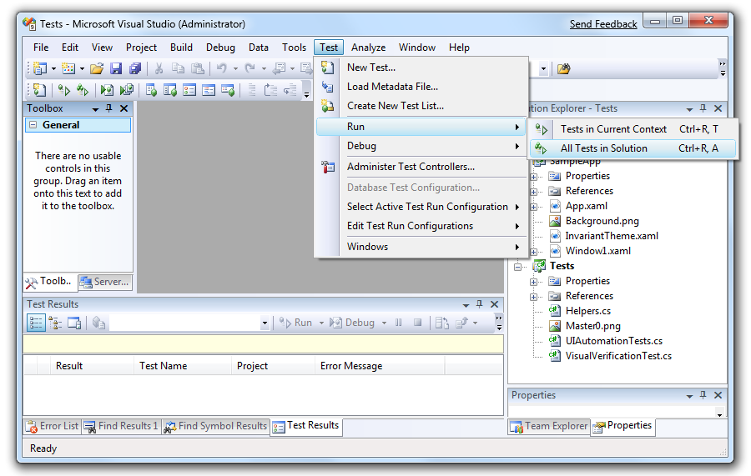

To run the tests from the command line, you use the MSTest.exe utility. The figure below demonstrates command-line usage:

C:\TestApi\Samples\MSTest\Tests\bin\Debug>
> dir
Volume in drive C has no label.
Volume Serial Number is B08A-2645

Directory of C:\TestApi\Samples\MSTest\Tests\bin\Debug

04/14/2009 12:50 PM <DIR> .
04/14/2009 12:50 PM <DIR> ..
04/13/2009 10:13 AM 40,960 FrameworkUtilities.dll
04/13/2009 10:13 AM 75,264 FrameworkUtilities.pdb
04/08/2009 04:36 PM 86,841 Master0.png
04/14/2009 12:01 PM 193,024 SampleApp.exe
04/14/2009 12:01 PM 24,064 SampleApp.pdb
04/14/2009 12:01 PM 6,656 Tests.dll
04/14/2009 12:01 PM 15,872 Tests.pdb
04/13/2009 10:15 AM 19,456 WpfUtilities.dll
04/13/2009 10:15 AM 42,496 WpfUtilities.pdb
9 File(s) 504,633 bytes
2 Dir(s) 95,076,524,032 bytes free

C:\> mstest /testcontainer:Tests.dll /resultsfile:TestResults.trx

Microsoft (R) Test Execution Command Line Tool Version 9.0.30729.1
Copyright (c) Microsoft Corporation. All rights reserved.

Loading Tests.dll...

Starting execution...

...

You can open the generated TestResults.trx (which is an XML file) in Internet Explorer or Visual Studio to view the test results.

For more information, refer to http://msdn.microsoft.com/en-us/library/ms182486(VS.80).aspx

